I understood this while doing the permutation problem

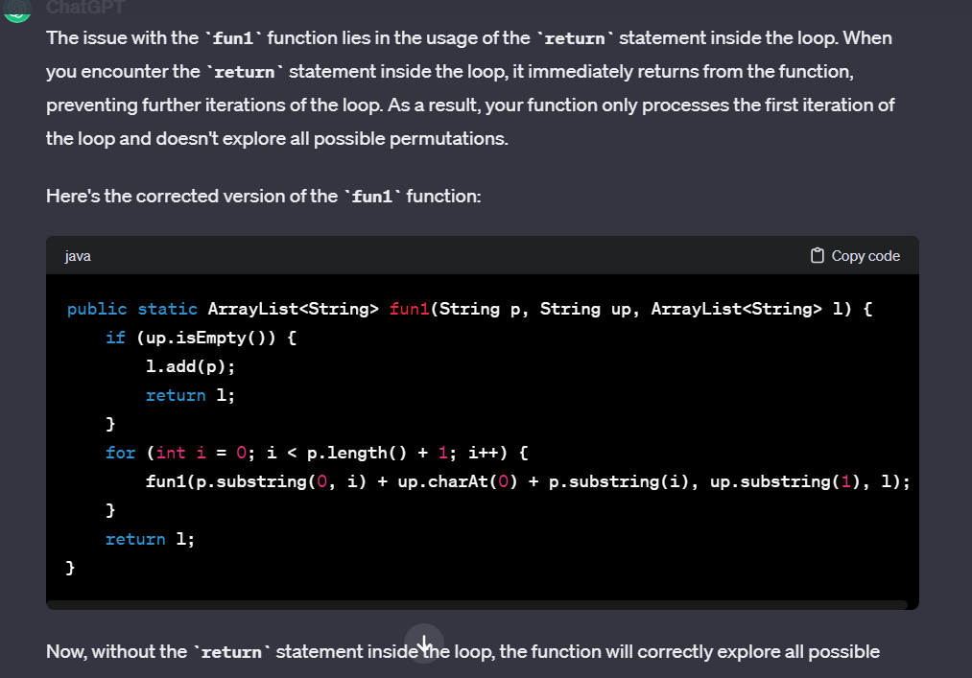

Leetcode sudoku solver problem (leetcode 37):

Do see the conditions kept inside it to check in a 3x3 matrix)  
